**Button Mash Master**

**Official Design Document**

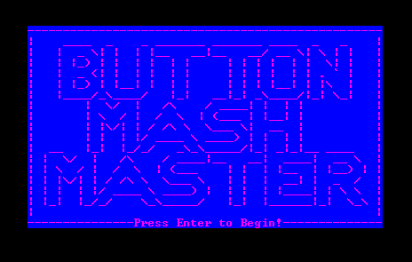

**© 2014 Team KingLek**

**A Game By:**

**Tan Kin Lek, Leong Weng Yan Ivan, Muhammad Shafik bin Mazlinan, Jasper Phua**

**Game idea/concept**

**Button Mash Master was inspired from a game found in arcades known as “The Bishi Bashi”. In Button Mash Master, multiple mini games are created to test the reaction and button pressing speed of the player.**

**Gameplay**

**The gameplay of each mini game varies from each other, but the goal will be either to clear it in the fastest time or to score as much points possible. Everything will played using the left, down or right arrow keys. After each mini game played, they will be given a rank based on how much they scored for that game.**

**Game Modes**

1. **Normal mode – aka practice mode**

**In this mode, players will be able to choose which mini game they want to play. After a game is played, the rank and score will be shown but it will not get recorded.**

1. **Random mode – aka Ranked mode**

**In this mode, players will have to go through seven mini games which are selected at random. After playing all seven games, the ranks will be taken from the games and points will be given for each rank (e.g. S rank will give 1000 points). The points will all be added up to get a score. If the score beats the one in the highscore, the player can enter 3 characters for his score and overwrite it to the highscore.**

**Mini Games List**

1. **Fill the candy jar**

**In this game, the objective is to fill the jar up with a hundred candies. A candy is added by pressing the left, down or right. The score for this game is the time, the faster the jar is filled, the more you will score. But for every candy which exceed a hundred is added, the time taken will increase by 1 second which will decrease the score.**

1. **Scream**

**The objective for this game is to charge up a power bar by pressing all the three keys. The bar will be constantly decreasing, so the player will have to mash the buttons fast enough to fill more than it decreases. The more power charged the higher the score will be.**

1. **Ice Kachang Eat-out**

**In this game, the objective is to chomp down as many ice kachang as you can. Press the left or right button to scoop a spoon of ice kachang. It takes 4 scoops to finish a bowl of ice kachang, the more bowls eaten, the more you score.**

1. **Don’t get spotted**

**The objective for this game is to move as many people from one end to the other. A sleepy guard will be on duty, when the guard is asleep, you can move a person by pressing all three buttons, but when he wakes up you have to stop moving. If you move when he is awake, you will move back to the starting point. The score will be the number of people crossed.**

1. **Table Flip**

**In this game you are a angry man and you feel like flipping the table. Press the left and right button to charge up your rage. The more you charge the further the table will fly, the further the table flies the higher the score.**

1. **Submarine Shootdown**

**The objective of this game is to shoot down as many submarine as you can. The player control three cannons and to fire the cannons, press the corresponding button (left button fire left cannon). Submarines will appear in front of the cannons, shoot the submarines as many time as possible when it is on screen to score.**

1. **Toilet Roll**

**In this game, the objective is to catch the falling toilet rolls at the holes on the sides. The player will have to press the left and right button at the same time to move the fingers into catching position. The score will increase with each toilet roll caught.**

1. **Photo Spam**

**The objective of this game is to take photos of the diamonds. Three objects will appear on the screen for two seconds and the player have to spam the corresponding button of where the diamond is at. The three objects will be shown six times, the first three times will contain only one diamond, the next two times will contain two diamonds and the last time with all three as diamonds. If the players press on the ‘poop’, they will not be able to score any more points for that set.**

1. **Pump The Rocket**

**In this game, the objective is to pump the rocket by pressing the left and right button. The left button will push the pump down, while the right will pull the pump up. Score will increase every time the pump is pulled up than push down. Pump it as many times as possible in ten seconds.**

1. **Find Twins**

**The objective for this game is to choose the two similar pictures out of the given three. Players have fifteen seconds to get as many twins as possible. To choose the pictures the player have to press two of the buttons that represent the pictures at the same time.**

**Problems encountered/ problems solved/ Lessons learnt**

* **Problems encountered**

**A huge problem that we encountered was that the framework given to us was not really suitable for the game we wanted to make. This was because our game needs to a high frame rate in order to play it smoothly, but printing method of the framework will make the output look like its flickering when the frame rate is set to anything above 10.**

**Since our game consist of multiple mini games, we decided to split the work by having each one of us do a few mini games. This led to a longer time required to create the games as it was too large a task and was not broken down properly to smaller task like e.g. this person do the mechanics while the other do the animation.**

**We ended up making similar games with each other and had to take a mini-game called Drumrolls out as it was really similar to Rockets and Table-Flip.**

* **Problems solved**

**For the framework problem, we solved it by implementing a function which prints everything in one frame, thus removing the flickering at 30 fps.**

* **Lesson learnt**

**For us, the lesson learnt during this three week would be to have better task breakdown, allocation and time management. Due to not doing that right this time, we had to reduce the number of mini games we planned to make. ☹**

**Knowledge applied**

**Mostly everything in C++ we learnt so far, from if statements to loops to enums. We also used a new feature (which was taught by shafick) call “classes”.**

**Future enhancements/improvements**

1. **Add sound to give a better feedback system when the player hits a button**
2. **More mini games**

**Task allocation and timeline**

* **Tan Kin Lek**

**Week 1**

* **Table flip game(started & done)**

**Week 2**

* **Don’t get spotted game(started & done)**
* **Menus and navigation between pages(started & done)**
* **Ranking System(started)**

**Week 3**

* **Trailer(Started & done)**
* **Ranking System(done)**
* **Jasper Phua**

**Week 1**

* **Submarine Game(started)**
* **IceKachang Game(started)**

**Week 2**

* **Submarine Game (done)**
* **IceKachang Game(done)**
* **Credits (started & done)**

**Week 3**

* **Presentation(started & done)**
* **Shafik**

**Week 1**

* **Framework Editing(Started and Done)**
* **Implemented “Graphics” function into the Framework to stop the flickering(Started & Done)**

**Week 2**

* **New controls for the game(Started and done)**
* **Implemented “directory” function into the Framework to help with multiple file stream(Started & Done)**
* **Scream game(started)**
* **Highscore (started)**

**Week 3**

* **Scream game(done)**
* **Find twins game(started & done)**
* **Highscore (done)**
* **Ivan leong**

**Week 1**

* **Toiletroll game (started & done)**

**Week 2**

* **Photospam game (started & done)**
* **Pump the rocket game (started & done)**
* **Random game mode (started & done)**

**Week 3**

* **Fill the candy jar (started & done)**
* **Document (started & done)**

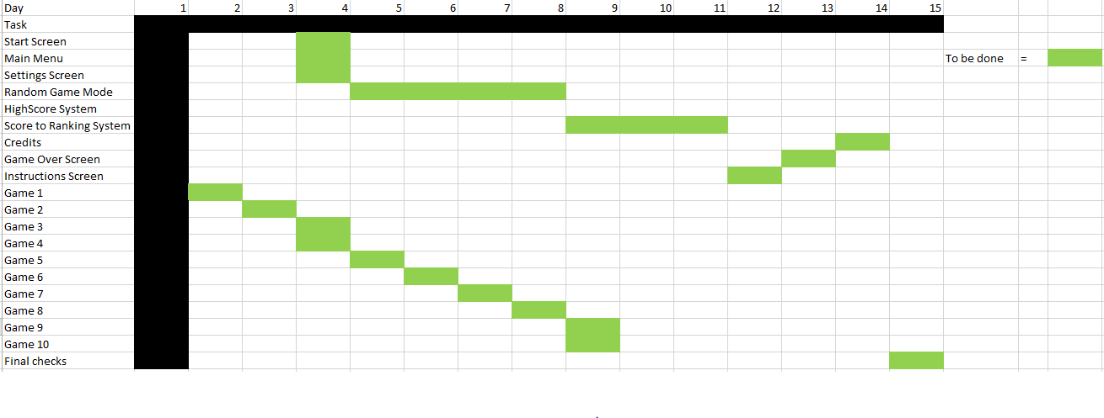**Gantt Chart**